Had People gone mad? What does it mean to buy on credit? Will this new found way of spending hurt or help the economy? What if we can’t pay? Continue to read other topics.

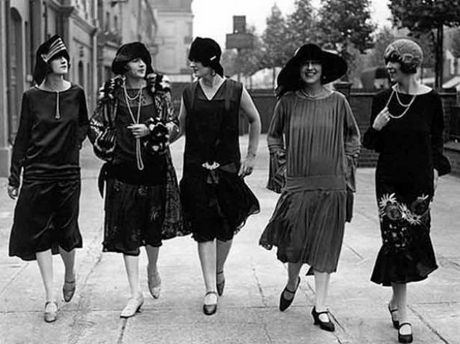

EXCLUSIVE NEWS TODAY Since 1895

BUYING ON CREDIT
Tuesday, May 29, 1926
THE
U.S. NEWS

Patricia Moore - Reporter

New forms of financing have allowed the American people to afford what perhaps the lower income community consider the finer things of life. No doubt, the more affluent see it as a luxury. The too expensive items became affordable for households. With this new found financing, the America people are out of control and families are spending beyond their financial means. The advertising companies have capitalized on people's hopes and dreams to sell more and better. Housewives now have more leisure time because now with available buy now and pay later credit; they have more time for the ladies social events. Household appliances, items like washing machines, vacuum cleaners, and refrigerators have given them more convenience and some has decided to work outside of the home.
For the housewife, the task of moving furniture and dragging the carpet and throw

Throw across the clotheslines to beat the dirt and dust out is never to be seen again. Thanks to the vacuum cleaner, this task is now obsolete. As a matter of fact, most households very seldom uses the clothes lines because washing machines in nearly every home. The purchased of the washing machine has eliminated those tiresome days of filling the outside laundry tub with water and scrubbing clothes until their hands were raw and red. But wait a minute, with

These appliances also acquired the use of electricity. The cost of electricity was also a luxury that had to be paid on monthly basis. No longer was there a need to light the kerosene lamps and to keep hard ice in the box to keep food cold. Thanks to the refrigerator, meats can be purchased on a weekly bases rather than daily. The hours saved in household work was countless. Has the America

Patricia Moore - Reporter

Advertising
U.S. AND WORLD ECONOMY
Advertising is becoming a major profitable business for advertising companies. Companies need the expertise of someone that can help sell their goods and move them off the shelves and floor quickly. Advertising companies that are aggressive are hired to advertise for the retailers merchandises. Merchants need these companies to convince Americans to buy their product. Advertisers are screaming in radios, putting
Buying on Credit

The Sell Pitch
Have a job; you can get credit. The consumers only need to promise to pay in twelve easy monthly installments. Automobiles purchases are on a rise. Consumers' debt has doubled. Can the consumers be helped responsible for the debt? Will this also contribute to a profound economic crisis in America? Perhaps only time will tell.



Printing ads in newspapers, and putting out signs in front windows of stores. Catchy slogans and pictures are some of the tools that advertisers use to lure customers for making purchases. One other means that the advertisers are using on the helpless consumers is a psycholocal approach as to why the item is best for the buyer.

The America people has endorsed a new motto. "Buy Now, Pay Later." Retailers that could afford to wait to be paid acquired new customers and maintained old customers. Department stores opened up lines of credit. If you have

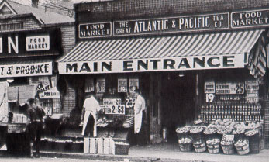

Because of the spending spree in the United States and spending spree in other countries, consumers have elevated corporate profits to unprecedented levels.
Businesses are striving, but customers are getting further in debts. New inventions are in the making, and so are patent attorneys. Manufacturers are founding new ways for fast production so that they can make larger profits. Jobs are available for those individuals that desire employment. Henry Ford has stepped out into a new realm other than making automobiles to a new venture to set up discount grocery stores. Some say they believe he is doing it out of spite to annoy local store owners. One good thing, we can say about that is, he is selling to his employees. Grocery store owners are furious.

Electricity and the Telephone
Two-thirds of all Americans household now has these conveniences. These are all contributors consumerism in America. Buy now and pay later credit has made it easier to purchase household items such as refrigerators and washing machines.

Chain Store Movement
Installment Credit
The Automobile Industry

The American people of moving on up. Chains of stores are multiplying. If you check our classified ads, you will find that there is one near you. Store chains such as Woolworths and A&P grocery store are expanding. Many banks, drugstore and cigar store chains are located in many cities.
Banks and department stores have to give the consumer more buying power by making installment payments. Automobiles, furniture, and mortgages were done with payment plans. The consumer society emphasized spending and borrowing.

Henry Ford and Alfred Sloan has been credited in their contribution to the national economy with automobile production. Ford made the automobile for affordable. Also his introduction of the automated assembly line, many people are at work with better wages. Alfred Sloan went for the luxury car sells and it also was a hit.

